Mealy and Moore Models of Finite State Machines
The most general model of a sequential circuit has inputs, outputs, and internal states. It is customary to distinguish between two models of sequential circuits: the Mealy model and the Moore model. Both are shown in Fig. 5.21. They differ only in the way the output is generated. In the Mealy model, the output is a function of both the present state and the input. In the Moore model, the output is a function of only the present state. A circuit may have both types of outputs. The two models of a sequential circuit are commonly referred to as a finite state machine, abbreviated FSM. The Mealy model of a sequential circuit is referred to as a Mealy FSM or Mealy machine. The Moore model is referred to as a Moore FSM or Moore machine.
Fig. 5.15 is state diagram of a Mealy machine showing both the input and output values, separated by a slash along the directed lines between the states.
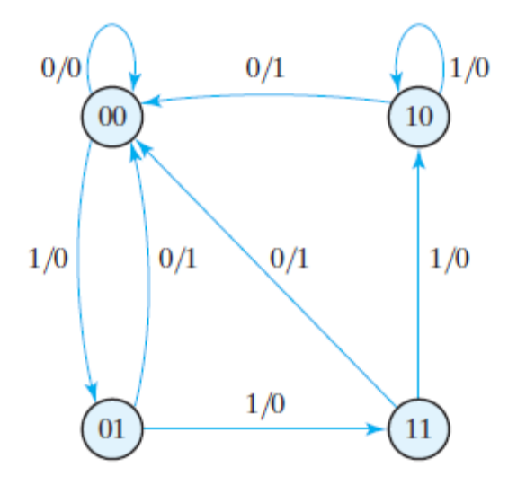
Fig. 5.15
Fig. 5.19 is the state diagram of a Moore machine which has only inputs marked along the directed lines. The outputs are the flip-flop states marked inside the circles. There may be other outputs also, which depend on present state only.
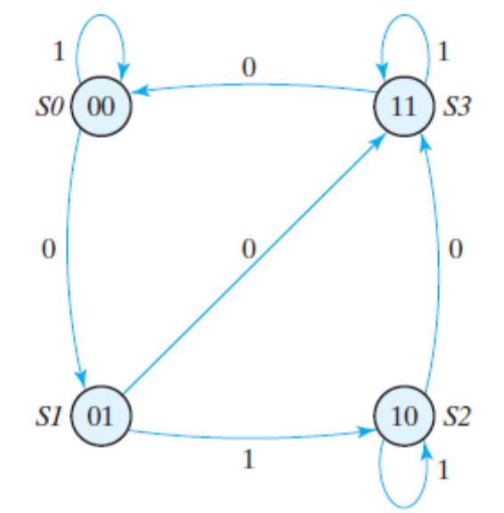
Fig. 5.19
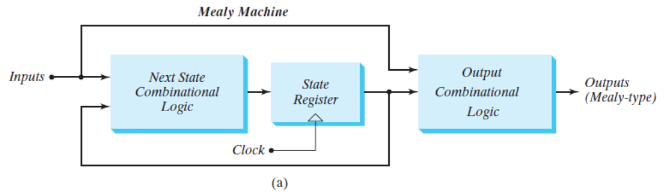
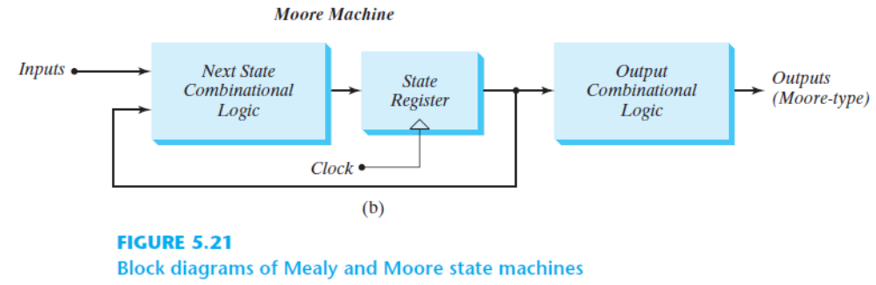
Consider an application where the speed of an automatically-controlled vehicle has to be regulated as follows. The vehicle is designed to run at some predetermined speed. However, due to some operational conditions the speed may exceed the desirable limit, in which case the vehicle has to be slowed down. To determine when such action is needed, the speed is measured at regular intervals. Let a binary signal w indicate whether the speed exceeds the required limit, such that w = 0 means that the speed is within acceptable range and w = 1 indicates excessive speed. The desired control strategy is that if w = 1 during two or more consecutive measurements, a control signal z must be asserted to cause the vehicle to slow down. Thus, z = 0 allows the current speed to be maintained, while z = 1 reduces the speed. Let a signal Clock define the required timing intervals, such that the speed is measured once during each clock cycle. Therefore, we wish to design a circuit that meets the following specification:
1. The circuit has one input, w, and one output, z.
2. All changes in the circuit occur on the positive edge of the clock signal.
3. The output z is equal to 1 if during two immediately preceding clock cycles the input w was equal to 1. Otherwise, the value of z is equal to 0.
From this specification it is apparent that the output z depends on both present and past values of w. Consider the sequence of values of the w and z signals for the clock cycles shown in Figure 6.2.
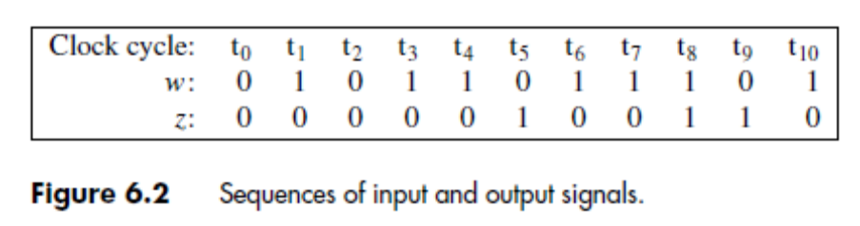
Since w = 1 in clock cycle t3 and remains equal to 1 in cycle t4, then z should be set to 1 in cycle t5. Similarly, z should be set to 1 in cycle t8 because w = 1 in cycles t6 and t7, and it should also be set to 1 in t9 because w = 1 in t7 and t8. As seen in the figure, for a given value of input w the output z may be either 0 or 1. For example, w = 0 during clock cycles t2 and t5, but z = 0 during t2 and z = 1 during t5. Similarly, w = 1 during t1 and t8, but z = 0 during t1 and z = 1 during t8. This means that z is not determined only by the present value of w, so there must exist different states in the circuit that determine the value of z. the state diagram of this FSM is shown in Fig. 6.3.

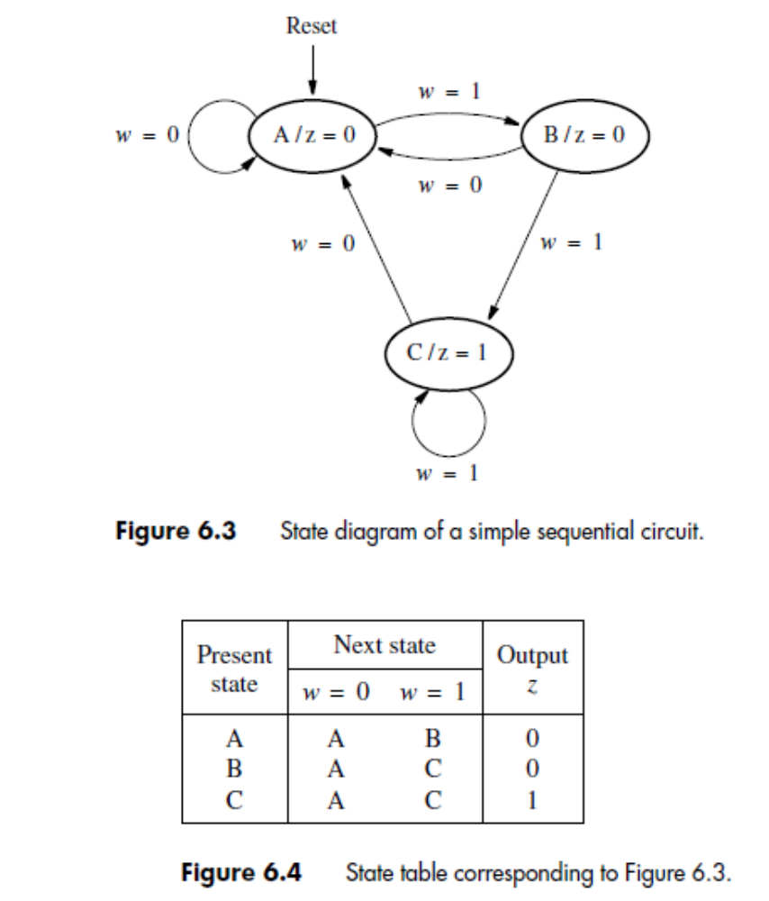
In the diagram we indicated that the Reset input is used to force the circuit into state A, regardless
of what state the circuit happens to be in.
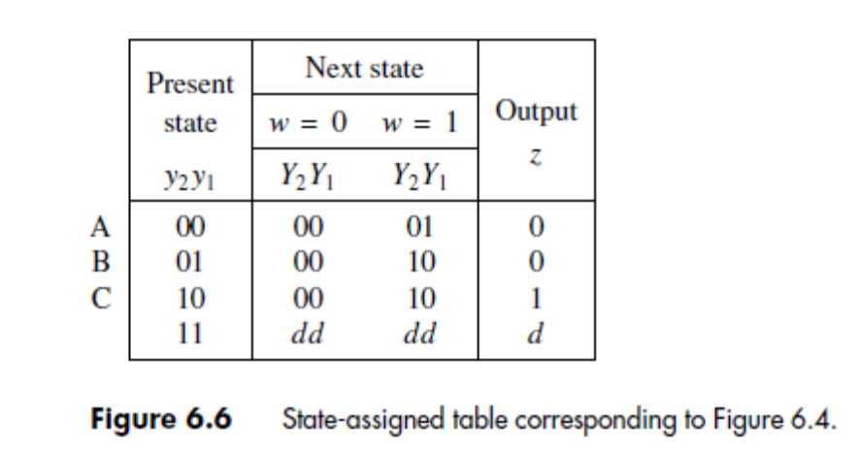
The signals y1 and y2 are also fed back to the combinational circuit that determines
the next state of the FSM. This circuit also uses the primary input signal w. Its outputs are
two signals, Y1 and Y2, which are used to set the state of the flip-flops. Each active edge
of the clock will cause the flip-flops to change their state according to the values of Y1 and
Y2 at that time. Therefore, Y1 and Y2 are called the next-state variables, and y1 and y2 are
called the present-state variables. We need to design a combinational circuit with inputs
w, y1, and y2, such that for all valuations of these inputs the outputs Y1 and Y2 will cause
the machine to move to the next state that satisfies our specification. The next step in the
design process is to create a truth table that defines this circuit, as well as the circuit that
generates z.
To produce the desired truth table, we assign a specific valuation of variables y1 and y2
to each state. One possible assignment is given in Figure 6.6, where the states A, B, and C
are represented by y2y1 = 00, 01, and 10, respectively. The fourth valuation, y2y1 = 11, is
not needed in this case.
The type of table given in Figure 6.6 is usually called a state-assigned table. This table can serve directly as a truth table for the output z with the inputs y1 and y2. Although for the next-state functions Y1 and Y2 the table does not have the appearance of a normal truth table, because there are two separate columns in the table for each value of w, it is obvious that the table includes all of the information that defines Y1 and Y2 in terms of valuations of inputs w, y1, and y2. From the State assigned table the following expressions can be derived:
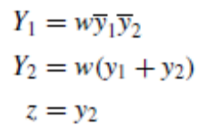
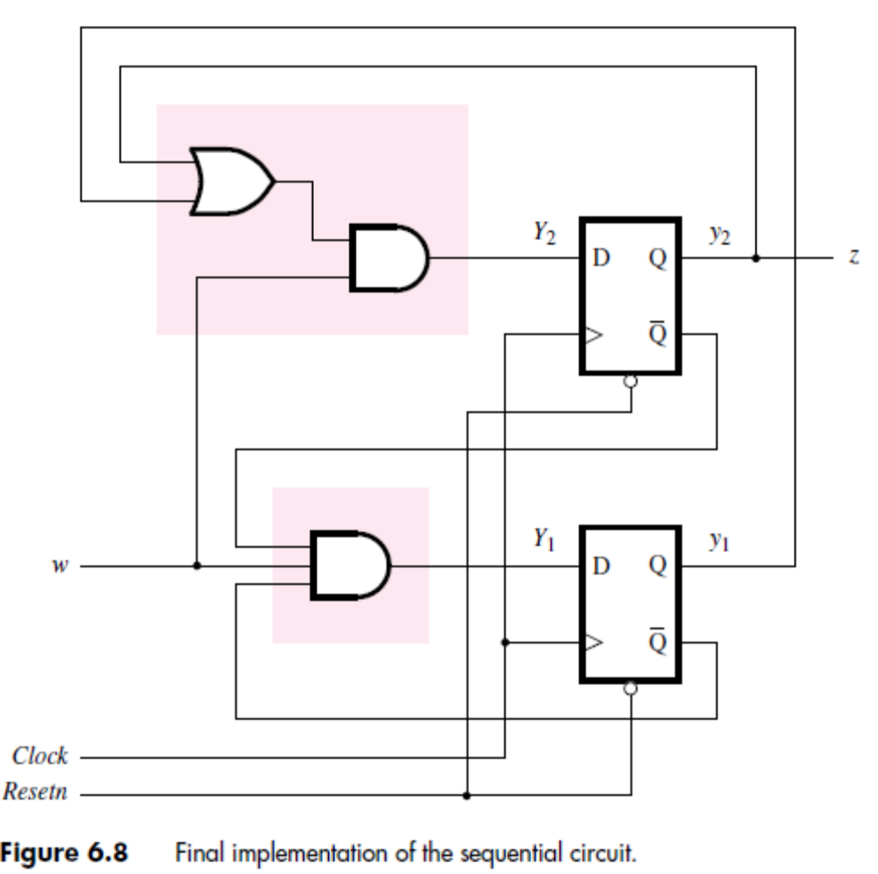
Algorithmic State Machine (ASM) Charts
The state diagrams and tables used so far are convenient for describing the behavior of FSMs that have only a few inputs and outputs. For larger machines the designers often use a different form of representation, called the algorithmic state machine (ASM) chart. An ASM chart is a type of flowchart that can be used to represent the state transitions and generated outputs for an FSM. The three types of elements used in ASM charts are depicted in Figure 6.81.
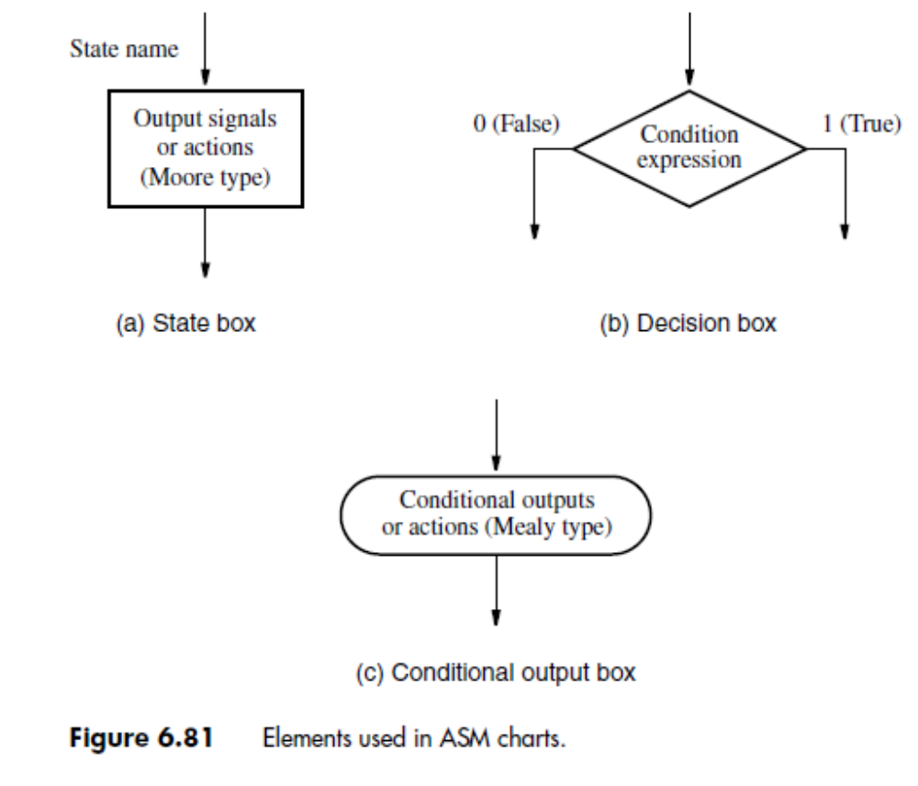
• State box – A rectangle represents a state of the FSM. It is equivalent to a node in the state diagram or a row in the state table. The name of the state is indicated outside the box in the top-left corner. The Moore-type outputs are listed inside the box. These are the outputs that depend only on the values of the state variables that define the state; we will refer to them simply as Moore outputs. It is customary to write only the name of the signal that has to be asserted. Thus it is sufficient to write z, rather than z = 1, to indicate that the output z must have the value 1. Also, it may be useful to indicate an action that must be taken; for example, Count ← Count + 1 specifies that the contents of a counter have to be incremented by 1. Of course, this is just a simple way of saying that the control signal that causes the counter to be incremented must be asserted.
• Decision box –A diamond indicates that the stated condition expression is to be tested and the exit path is to be chosen accordingly. The condition expression consists of one or more inputs to the FSM. For example, w indicates that the decision is based on the value of the input w, whereas w1 ・ w2 indicates that the true path is taken if w1 = w2 = 1 and the false path is taken otherwise.
• Conditional output box – An oval denotes the output signals that are of Mealy type. These outputs depend on the values of the state variables and the inputs of the FSM; we will refer to these outputs simply as Mealy outputs. The condition that determines whether such outputs are generated is specified in a decision box. Figure 6.82 gives the ASM chart that represents the FSM in Figure 6.3. The transitions between state boxes depend on the decisions made by testing the value of the input variable w. In each case if w = 0, the exit path from a decision box leads to state A. If w = 1, then a transition from A to B or from B to C takes place. If w = 1 in state C, then the FSM stays in that state. The chart specifies a Moore output z, which is asserted only in state C, as indicated in the state box. In states A and B, the value of z is 0 (not asserted), which is implied by leaving the corresponding state boxes blank.
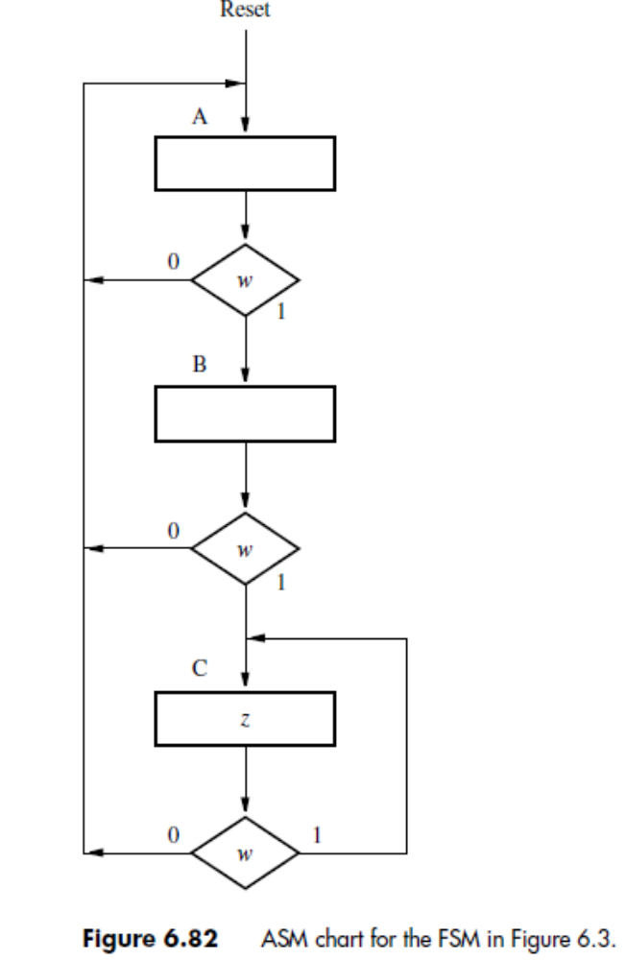
6.3 Mealy State Model
Our introductory examples were sequential circuits in which each state had specific values of the output signals associated with it. As we explained at the beginning of the chapter, such finite state machines are said to be of Moore type. We will now explore the concept of Mealy-type machines in which the output values are generated based on both the state of the circuit and the present values of its inputs. This provides additional flexibility in the design of sequential circuits. We will introduce the Mealy-type machines, using a slightly altered version of a previous example. The essence of the first sequential circuit in Section 6.1 is to generate an output z = 1 whenever a second occurrence of the input w = 1 is detected in consecutive clock cycles. The specification requires that the output z be equal to 1 in the clock cycle that follows the detection of the second occurrence of w = 1. Suppose now that we eliminate this latter requirement and specify instead that the output z should be equal to 1 in the same clock cycle when the second occurrence of w = 1 is detected. Then a suitable input-output sequence may be as shown in Figure 6.22. To see how we can realize the behavior given in this table, we begin by selecting a starting state, A. As long as w = 0, the machine should remain in state A, producing an output z = 0. When w = 1, the machine has to move to a new state, B, to record the fact that an input of 1 has occurred. If w remains equal to 1 when the machine is in state B, which happens if w = 1 for at least two consecutive clock cycles, the machine should remain in state B and produce an output z = 1. As soon as w becomes 0, z should immediately become 0 and the machine should move back to state A at the next active edge of the clock. Thus the behavior specified in Figure 6.22 can be achieved with a two-state machine, which has a state diagram shown in Figure 6.23.
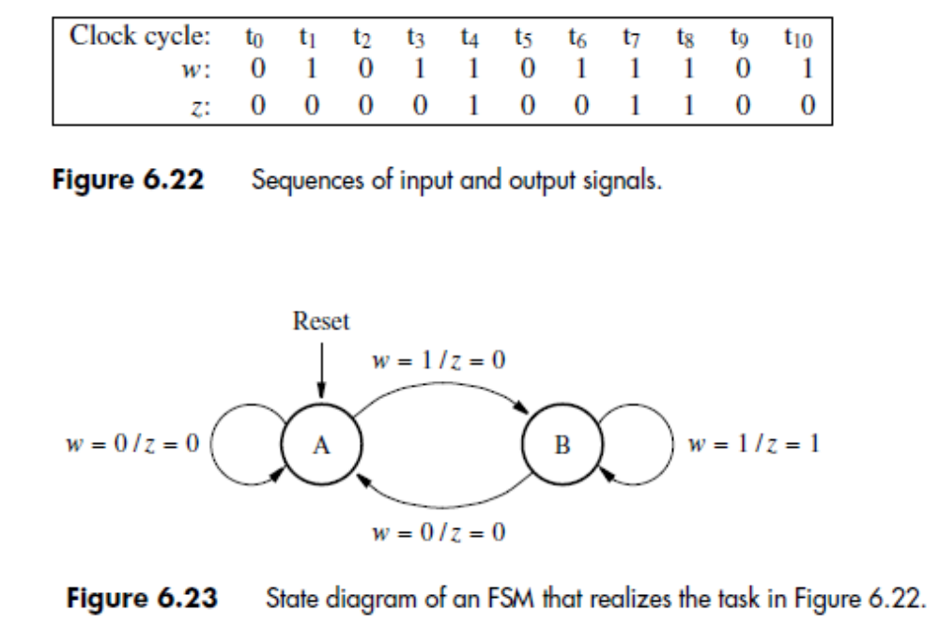
Only two states are needed because we have allowed the output value to depend on the present value of the input as well as the present state of the machine. The diagram indicates that if the machine is in state A, it will remain in state A if w = 0 and the output will be 0. This is indicated by an arc with the label w = 0/z = 0. When w becomes 1, the output stays at 0 until the machine moves to state B at the next active clock edge. This is denoted by the arc from A to B with the label w = 1/z = 0. In state B the output will be 1 if w = 1, and the machine will remain in state B, as indicated by the label w = 1/z = 1 on the corresponding arc. However, if w = 0 in state B, then the output will be 0 and a transition to state A will take place at the next active clock edge. A key point to understand is that during the present clock cycle the output value corresponds to the label on the arc emanating from the present-state node.
The state table is shown in Figure 6.24. The table shows that the output z depends on the present value of input w and not just on the present state. Figure 6.25 gives the state-assigned table. Because there are only two states, it is sufficient to use a single state variable, y. Assuming that y is realized as a D-type flip-flop, the required next-state and output expressions are
Y = D = w
z = wy
The resulting circuit is presented in Figure 6.26 along with a timing diagram. The timing diagram corresponds to the input-output sequences in Figure 6.22.
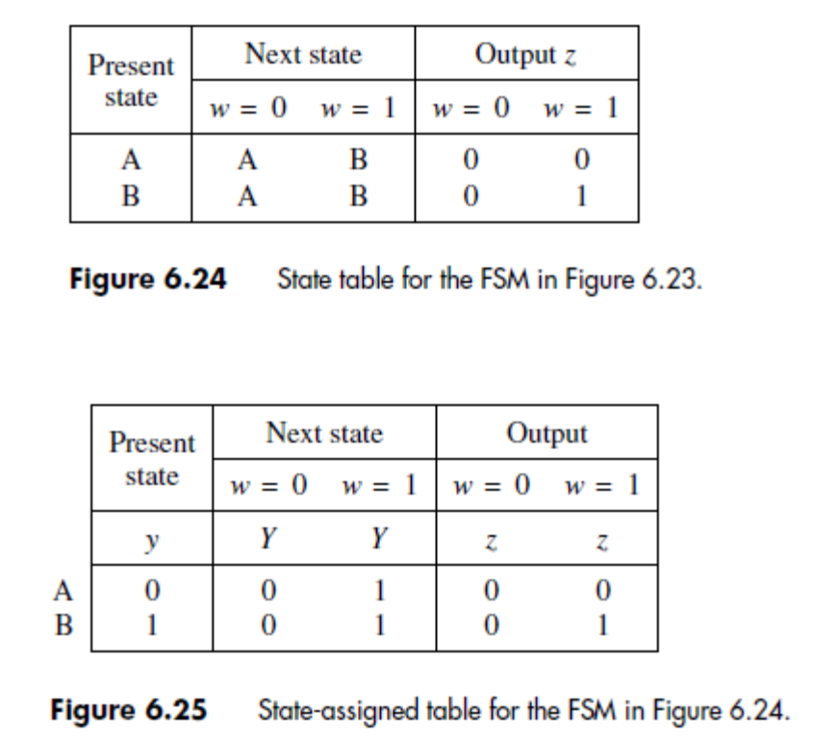
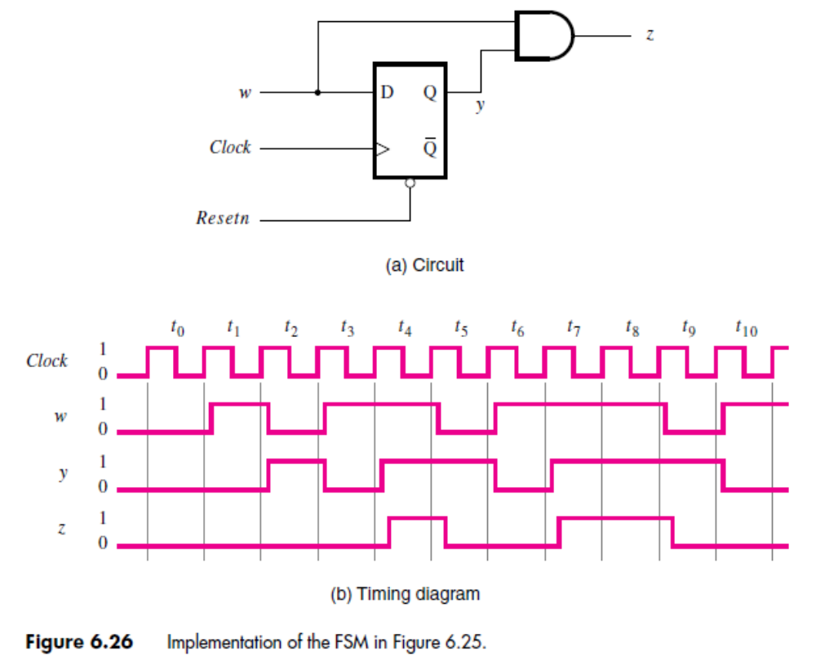
Figure 6.83 provides an example with Mealy outputs. This chart represents the FSM in Figure 6.23. The output, z, is equal to 1 when the machine is in state B and w = 1. This is indicated using the conditional output box. In all other cases the value of z is 0, which is implied by not specifying z as an output of state B for w = 0 and state A for w equal to 0 or 1.

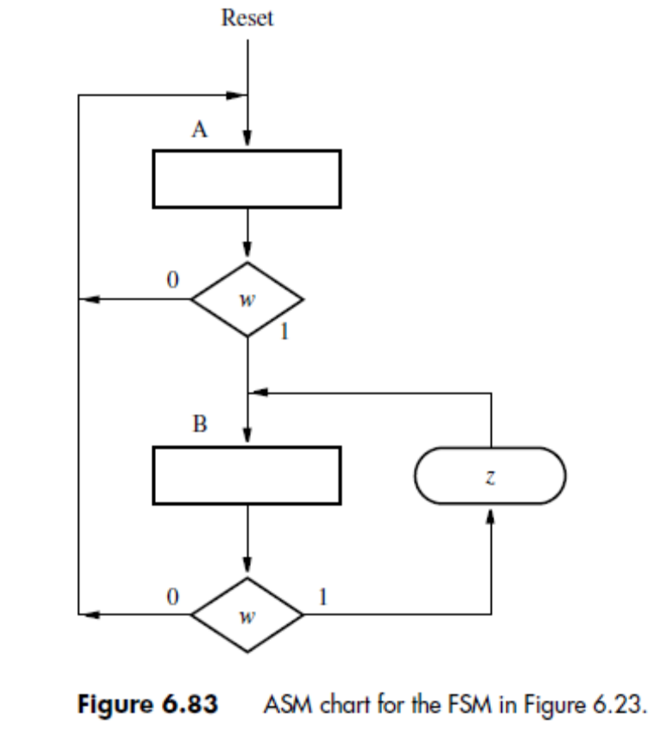

ASM charts are similar to traditional flowcharts. Unlike a traditional flowchart, the ASM chart includes timing information because it implicitly specifies that the FSM changes (flows) from one state to another only after each active clock edge. The examples of ASM charts presented here are quite simple. We have used them to introduce the ASM chart terminology by giving examples of state, decision, and conditional-output boxes. Another term sometimes applied to ASM charts is ASM block, which refers to a single state box and any decision and conditional-output boxes that the state box may be connected to. The ASM charts can be used to describe complex circuits that include one or more finite state machines and other circuitry such as registers, shift registers, counters, adders, and multipliers.

